**Project Objective**

The objective of the project is to build a website targeted towards male audience, which enables the user to create groups based on the individual work or interest. For example: a person could have hobbies such as GYM, coding, MMA; each of these hobbies can have its own group with different/same members on it.

**Implementation Plan (Target for week 11)**

Profile Page

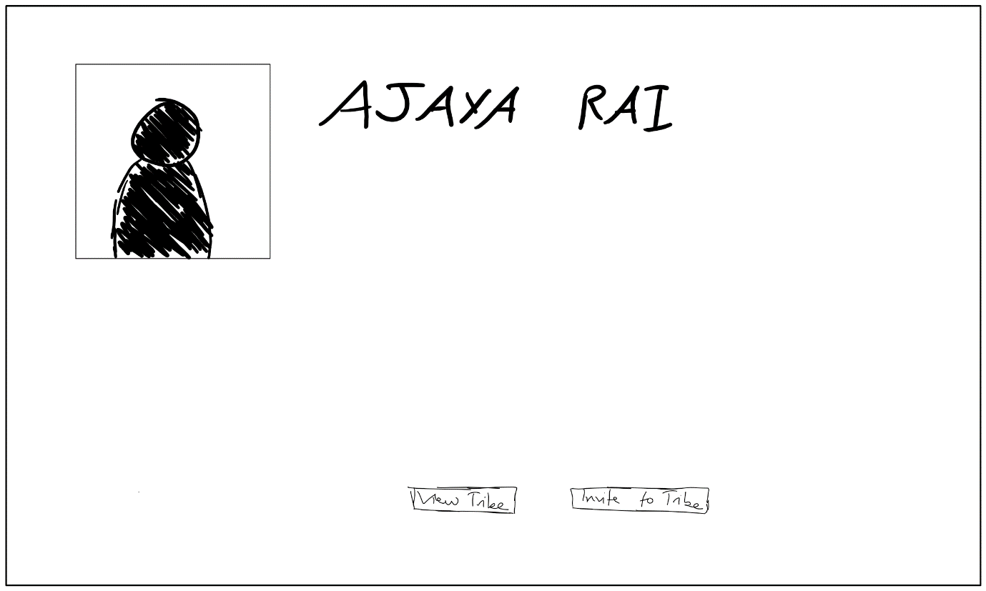

Home Page

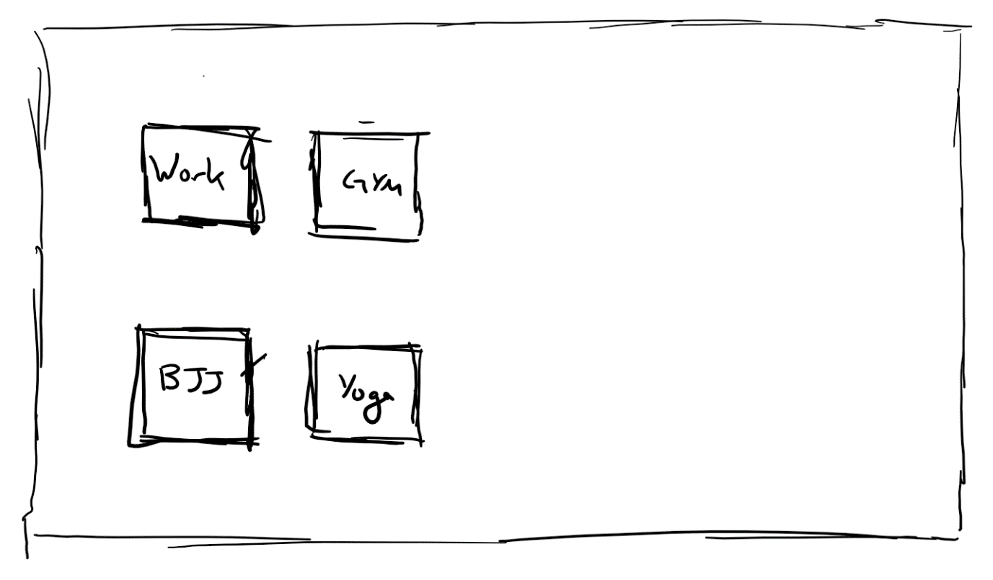

Group page

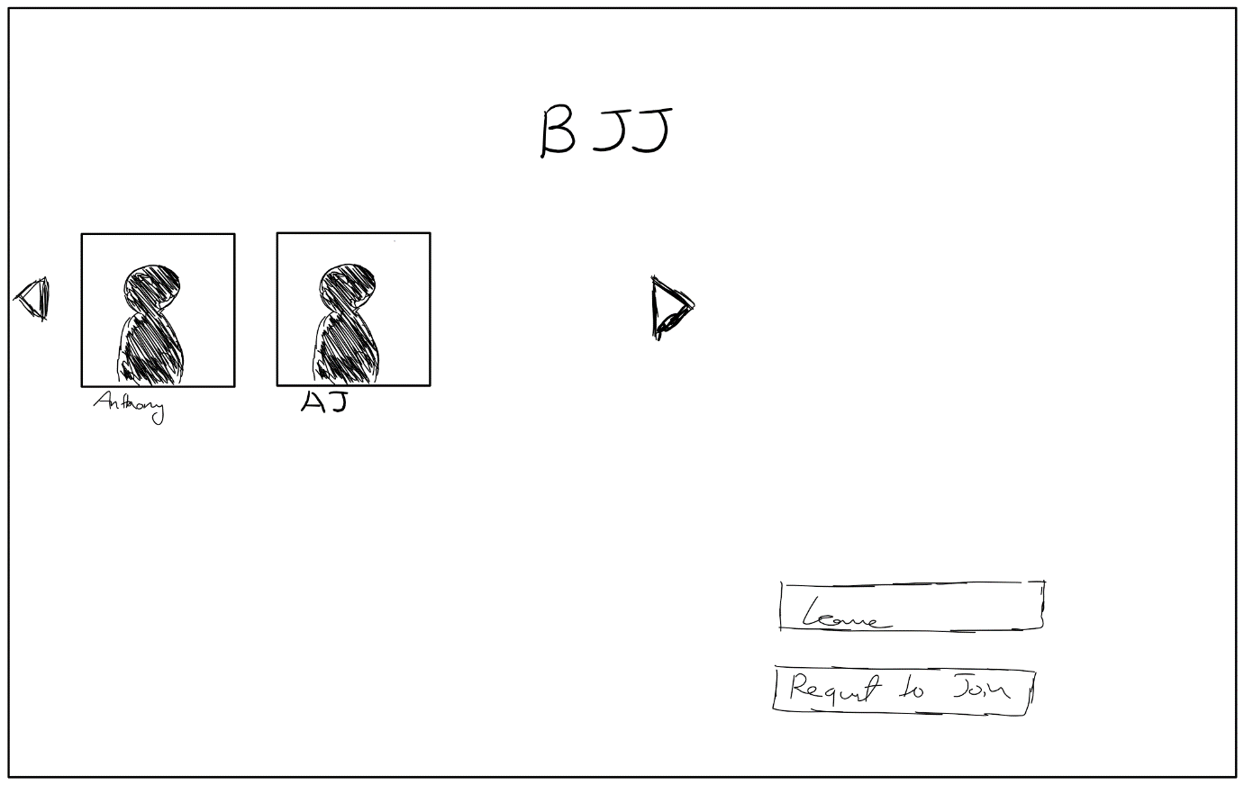

Search page

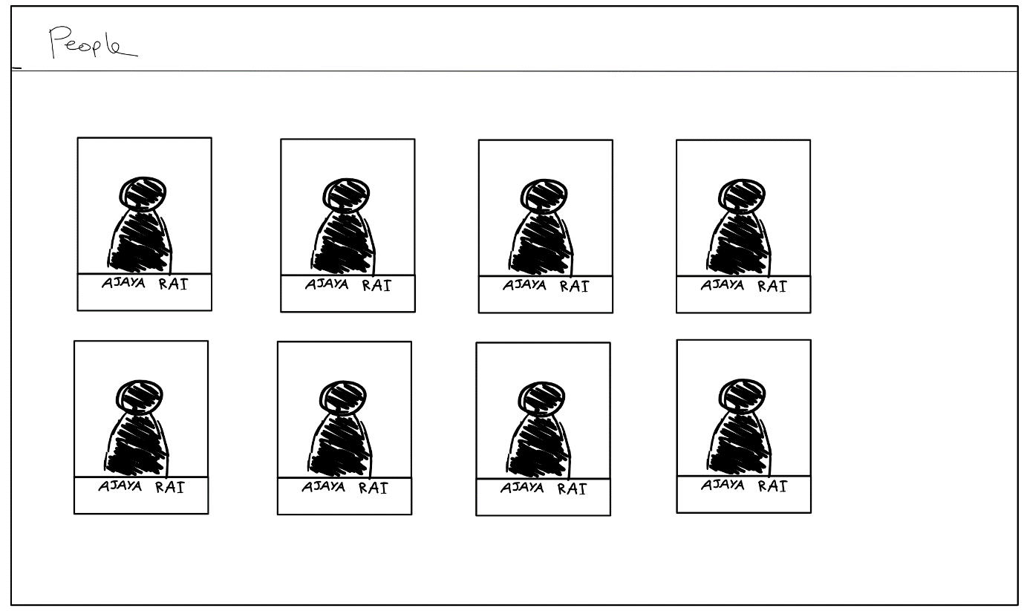

Header



**Implementation Plan (Target for the whole year)**

Profile Page

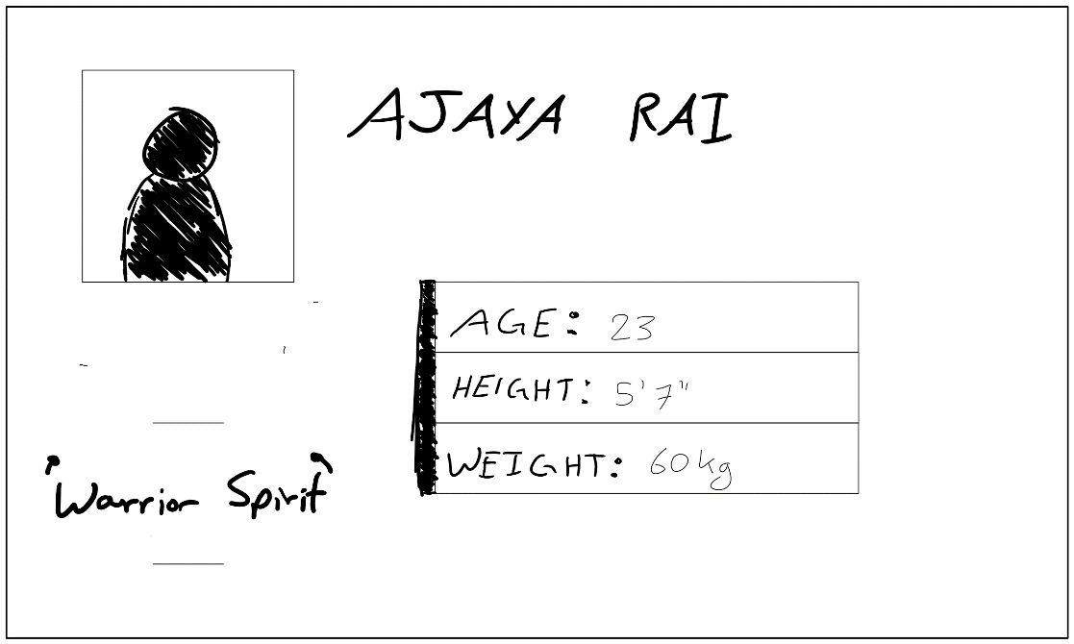

Home Page

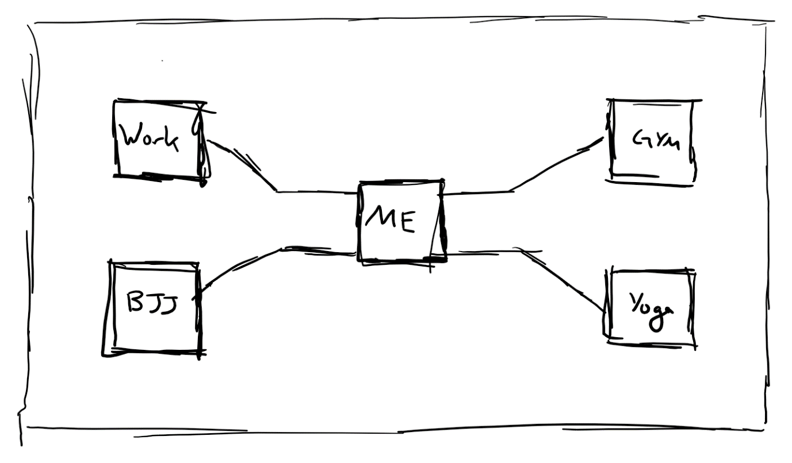

Group Page

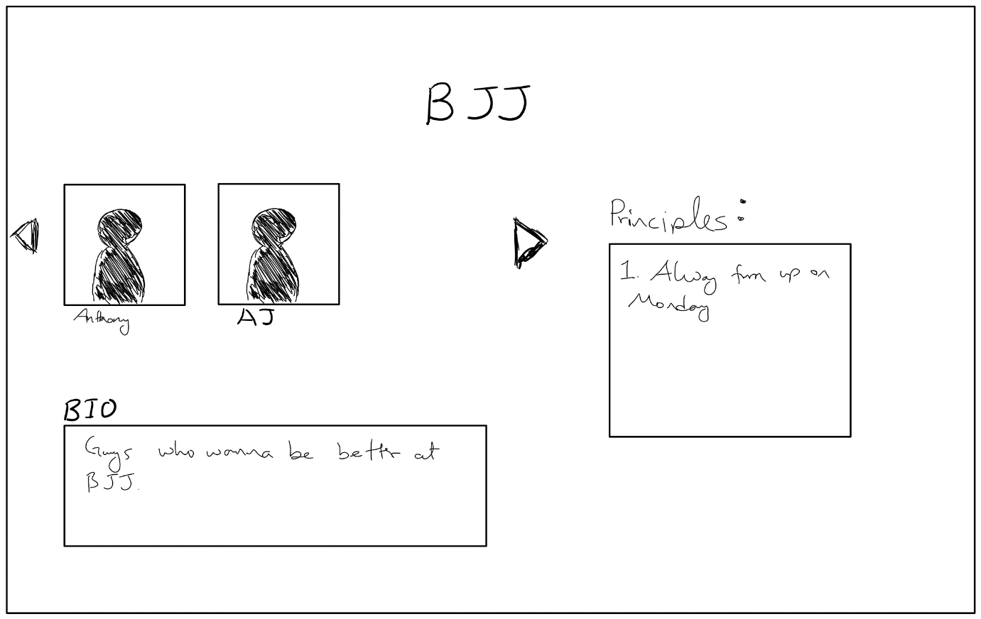

Header





Search Page

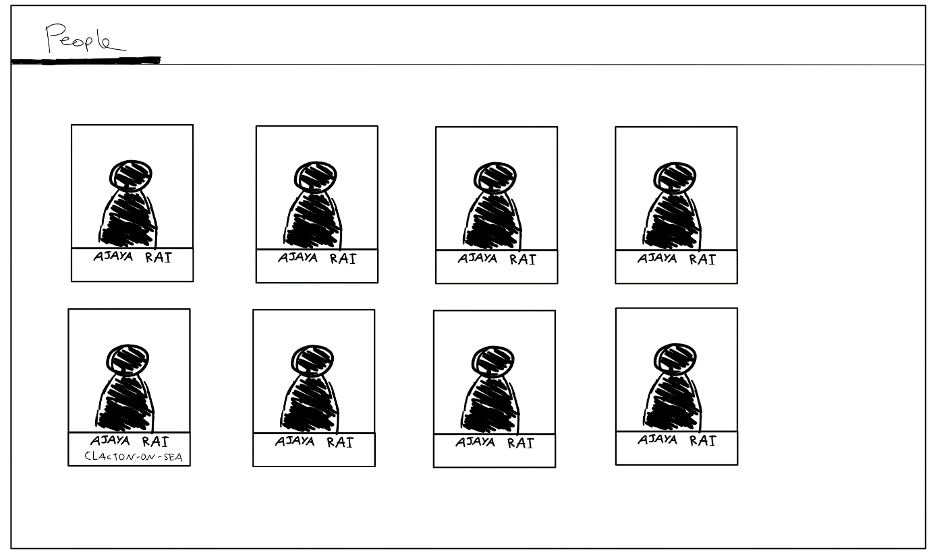

OVERALL, the main objective of the MVP is to produce a product which logic works, after that focus should be on making the website bug-free and designing so that it looks better.

**Logic**

Please look at the ‘Logic 2’ file for a flow-chart. Most likely the logic on the file would be too much to implement within a year.

**Risks**

Risks that may prevent me from finishing the project, include:

1. Using technologies that I am not confident with; ReactJS and Firebase. So, firstly do not completely know how I can solve the complex logics. For example, how do I build a group page, where different users’ pictures and names are drawn from the Firebase DB and shown to the screen. Secondly, the group page has buttons which should be shown to the appropriate users, e.g. if user A hasn’t joined the group, then he sees the ‘Request to Join’ button. Whereas user B who has joined the group, sees the ‘Leave’ button. How do I go about solving this logic?

I would only guess that the logic would be similar to other programming languages like PHP and MYSQL which I am familiar with, however, there could be somethings that are different in ReactJS and Firebase. For example, it seems that for ‘Routing’, in ReactJS, I would have to download a module.

Furthermore, ReactJS is a single page app, where as PHP tends to be multiple page app. So, learning this and implementation this new way (single page app) could be a challenge.

If I found the ReactJS and Firebase too difficult, then I must drop some of the features planned on here.

1. For evaluation of my project, I would like to involve real people and let them test the web-app, where I will like to observe their usage and in the end request them to give it a rating. Although, I wanted to do this face-to-face, due to the COVID situation, this may not be possible. If this is not possible, then I would like to deploy the app. And request people to test it via online. I could observe their usage via screenshare. Furthermore, I am house sharing with 3 other people, so I could also asked them to test it.

**Context**

*Please look at the ‘Background Research’ document for context.*